Data Visualization Exercise

David Jorgensen
College of Science & Tech, Bellevue University
DSC500-T302 Introduction to Data Science
Dr. Kathy Harris
November 2, 2025

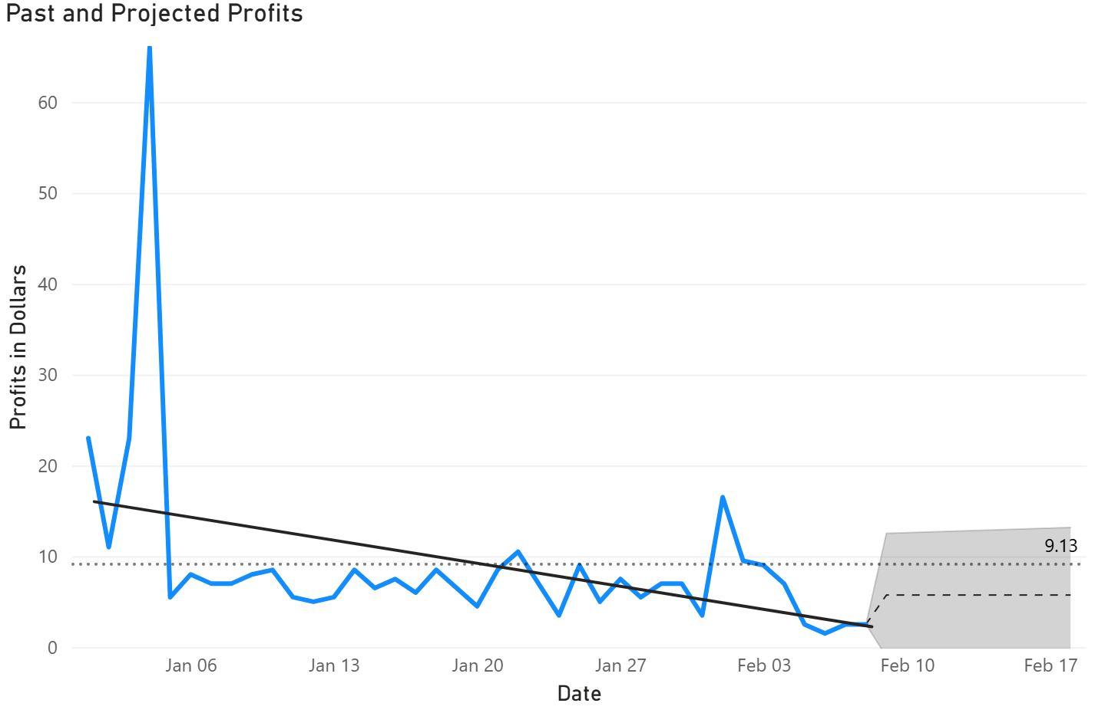
Data visualization plays a crucial role in understanding complex datasets and uncovering actionable insights. By leveraging various chart types and graphical representations, we can analyze business performance, identify trends, and make informed decisions. This exercise explores the use of multiple visualization techniques to interpret profit data and support strategic planning within a retail context.

This line graph, “Past and Projected Profits,” displays daily profits from January 1 to February 10, with a projection extending to February 17. The blue line represents actual profits, while the shaded area shows projected profits within a 10% margin of error. The graph includes two reference lines: the overall average profit ($9.13) and a trend line indicating the general direction of profits over time.
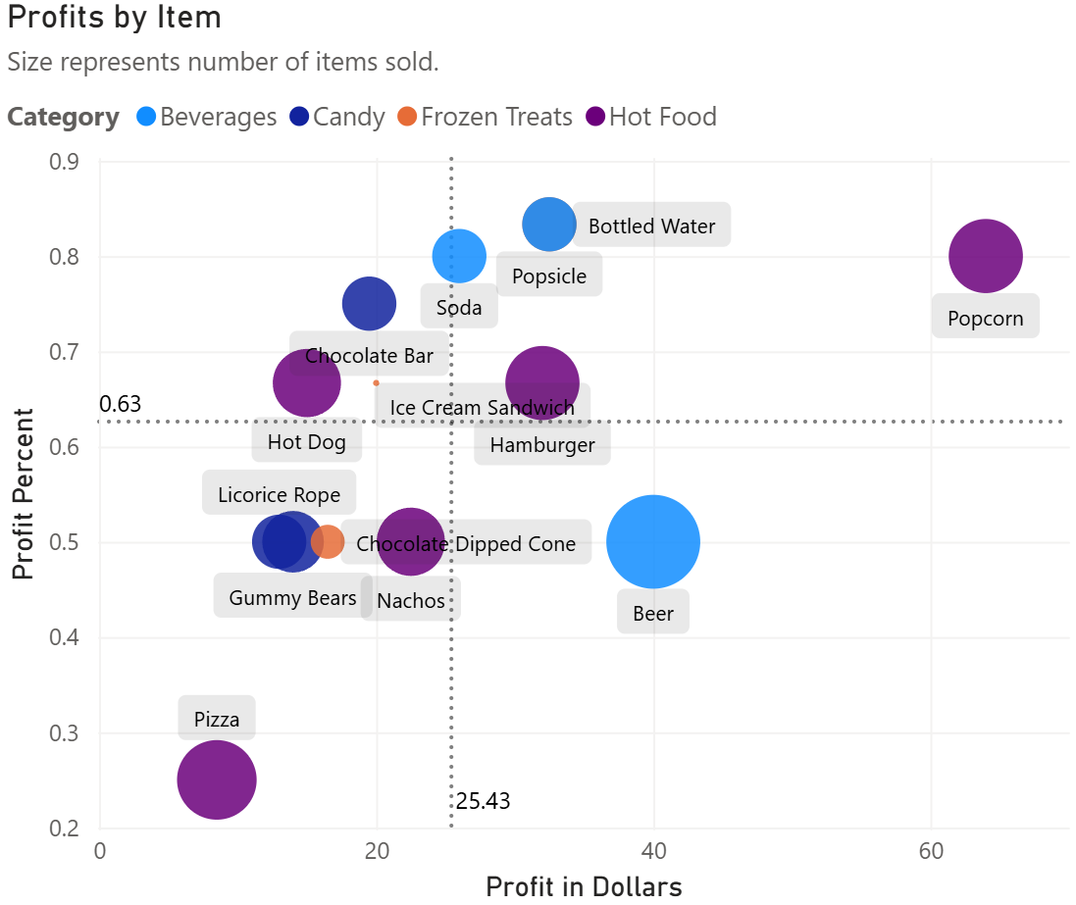
A line graph is ideal for showing changes over time, making it easy to spot trends, fluctuations, and outliers. Including projections and reference lines adds context for decision-making and performance evaluation. From this line graph, we see a sharp spike in profits early in January, followed by a decline and stabilization at a lower level. The trend line suggests a slight downward trajectory in profits over the observed period. The average profit line provides a benchmark for evaluating daily performance. The projection helps anticipate future performance and plan accordingly.

This cluster graph, “Profits by Item,” plots each product by its total profit (X-axis) and profit percent (Y-axis). Dot color indicates product category (e.g., Beverages, Candy, Frozen Treats, Hot Food), and dot size reflects the number of items sold. The chart also marks average profit percent (63%) and average total profit per item ($25.43).
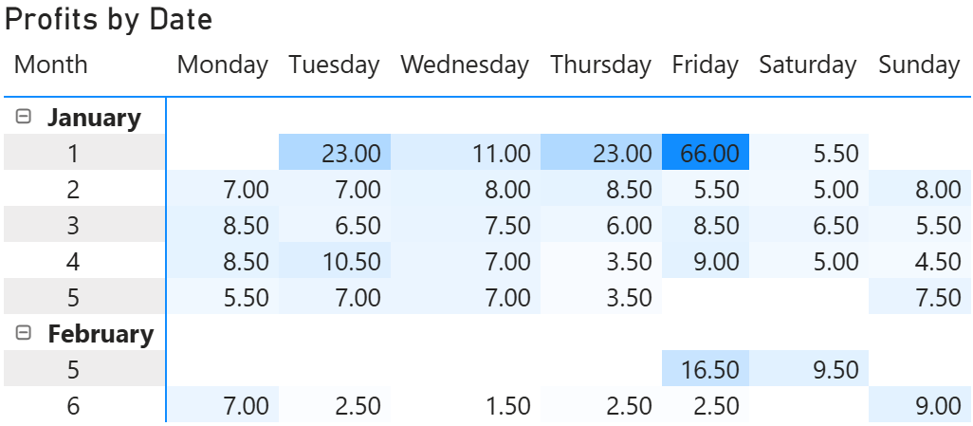
A bubble chart effectively visualizes multi-dimensional data, allowing simultaneous comparison of profit, profit percent, sales volume, and category. This helps identify top performers and underperformers. For example, this chart reveals that popcorn stands out with high profit in dollars and percent, indicating strong performance. Some items (e.g., Pizza) have low profit percent and dollar value, suggesting they may be less profitable. Small dots represent items that are niche or ill-suited for the current time of year and are probably not worth continuing to sell at present, such as frozen treats.

This matrix chart, “Profits by Date,” resembles a calendar, with weeks as rows and days of the week as columns. Each cell shows the profit earned on that day, with darker colors indicating higher profits.
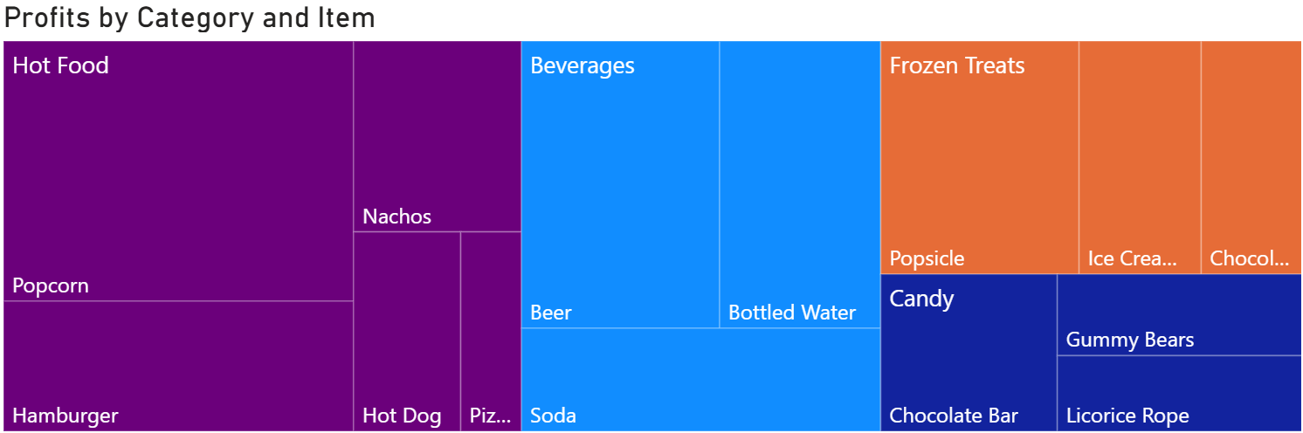
A heatmap calendar is perfect for visualizing temporal patterns and quickly identifying peak and off-peak days. It supports operational decisions, such as staffing and inventory management. From this calendar, we can observe that Fridays in January are consistently the most profitable days, especially January 2nd. Weekends and some weekdays show lower profits, suggesting days without games or games that garnered low attendance. The heatmap format makes it easy to spot high and low-profit days, aiding in scheduling and promotional planning.

This tree map, “Profits by Category and Item,” divides profits by category (color-coded) and item (zone size). Larger zones represent items with higher profits, while smaller zones indicate less profitable products.
Tree maps are excellent for showing part-to-whole relationships, making it easy to compare the relative contribution of each item and category to overall profits. This aids in strategic product management and marketing. This tree map reveals that Hot Food and Beverages occupy the largest areas, indicating they are the most profitable categories. Within categories, items like Popcorn and Beer stand out for their individual contributions, indicating we should consider prioritizing focus on these high-profit items during sales or promotional campaigns.

